R&E: How to Become a Competitive Applicant
2/21/24

Start time: 8:12 PM
End time: 8:54 PM

Download the slides here!

PharmCAS
- Service where you can apply to multiple PharmD programs
- For the 2024-2025 cycle: admission cycle begins mid-July 2024 + closes mid-July 2025
  - Specific dates (i.e. priority + final deadlines) depend on schools you apply to
- Make sure you have all the materials:
  - Transcripts
  - Evaluations (letters of rec)
  - PCAT scores (if necessary)
    - No PCAT testing dates offered during 2024-25 admissions cycle + beyond
- Personal statement
  - Write down all experiences + start brainstorming!
  - Give yourself enough time to make plenty of revisions + to make feedback from multiple ppl
    - Common to rewrite essays multiple times
  - Use resources available at UCD!
    - UWP104F
      - One assignment includes personal statement
      - Can get feedback from professor/peers
    - HPA
    - SASC (student academic success center)
- Letters of recommendation
  - Schools require 1-4 letters
  - Receive them a month before deadline (allows more time to submit)
- GPA/Grades
  - GPA
    - Minimum = 2.6-4.0 cumulative
    - PharmCAS calculates GPA for you so it may be different from school’s
      - Includes failed + repeated courses
      - Includes grades + credits from transcripts where course was originally taken
      - Divides each year level GPA into science, non-science, overall
  - Competitive candidate
    - > 3.0 GPA
    - EX: UCSF average cumulative GPA: 3.43
      - Average science GPA: 3.30

Prerequisites
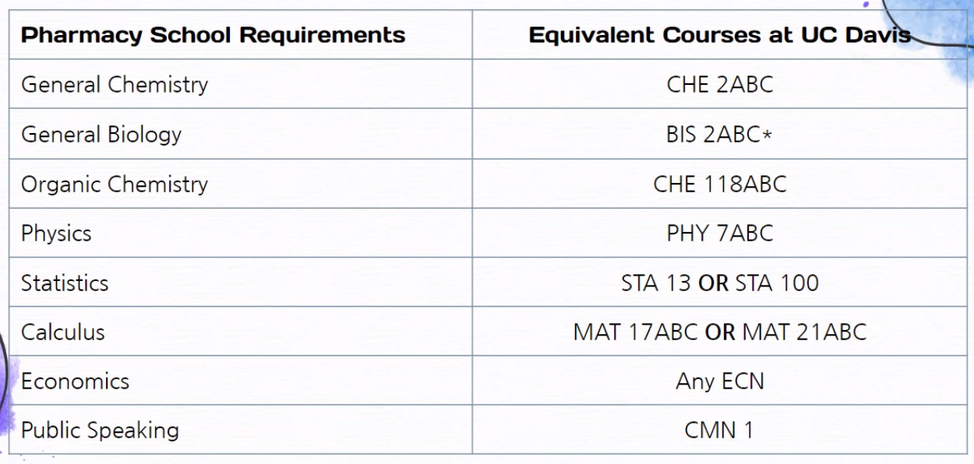
- NOTE: some schools take MIC 102 or MIC103L instead of BIS 2C
- Communicate / double-check with schools directly for any questions!
- Some schools may also require:
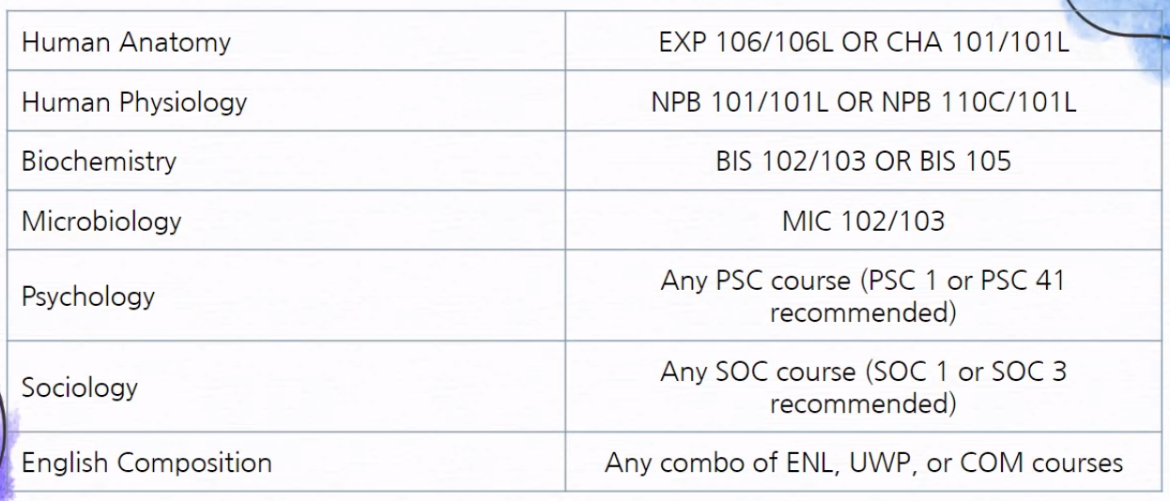

Extracurriculars
- Research
  - Helpful if you want to go into research
  - Check UC Davis undergraduate research website + email professors
- Clubs
  - Can become active member of PPC (+ write on PharmCAS app)
  - Gain leadership experience
- Pharmacy-related jobs
  - Can become pharmacy technician
  - EMT
  - Medical scribe
  - Medical assistant
  - More jobs not listed here!
- HRIs, volunteering, clinics
  - Look out for future HRIs (health-related internships) on ICC website
  - Gain first-hand clinic experience
- Note: experiences don’t have to be pharmacy-related
  - More important to find what you’re passionate about to make a good + valuable experience

Letters of Rec
- Start early!
  - Start building relationships with professors
  - Attend office hours
  - Get to know professor
  - Ask questions!
- Choose wisely
  - Make sure you ask people who are able to write a strong letter that speaks to your character
  - Schools require LORs from specific people
    - EX: some schools require one from science professor
- Ask early
  - Give letter-writer plenty of time
  - Be prepared to submit supplemental info (resume, CV, personal statement)
  - Some professors have a cap on how many letters they will write so ask early!

Priority Deadlines
- Facts
  - Early decisions no longer offered as option in PharmCAS
  - Encouraged to apply early to program early in admissions cycle
  - Can apply to one/more schools with priority deadline
  - PharmCAS recommends applicant to submit 2 weeks before deadlines
    - Avoid potential technological issues
- Examples
  - UCSF PharmD Program
    - Priority deadline: Oct 3rd
    - Final deadline: Dec 1st
  - UOP PharmD Program
    - Priority deadline: Oct 3rd
    - Final deadline: Feb 1st
  - UCSD PharmD Program
    - Early submission: Aug 31st
    - Regular cycle: Dec 1st
- Find more info here: https://www.pharmcas.org/school-directory/pharmd-directory

Q&A Time
- Introductions (panelists who have applied this cycle)
- Arti Naik: graduated last spring with Nutritional Science major
  - Took gap year + applied this last cycle
- Christine Phan: 4th year Pharmaceutical Chemistry major
- Questions
- What is one thing you struggled with when you were navigating the PharmCAS?
  - Arti
    - Transcript entry: have to input all grades + there’s certain categories/subjects for each one
    - Important to fulfill requirements for each school you’re applying to
    - Highly recommend making a school list + take a look at websites to see what requirements each school has
    - UCSD requires a class that I did not take at Davis → had to take it at community college
  - Christine
    - PharmCAS was quite straightforward (like applying to colleges) but manually inputting grades was tedious
    - Have to manually input name of course, credits, & grade you got
    - Also have to input classes that you’ve taken at highschool if you received AP credit for prerequisites (e.g. AP Psychology)
    - Have to be meticulous to make sure courses match official transcript or it could delay the process
- Did you make a PharmCAS account before the application opened in July?
  - Arti
    - No, I did not know you could do that
    - Would definitely look into that if you’re curious about what the previous cycle’s questions were
    - Can make an account for upcoming cycle
    - Have questions for personal statements + supplemental essay questions
  - Christine
    - Yes, I made an account beforehand but I didn’t look much into it
    - Started personal statements before application started
    - Started application when it opened in July
- How many pharmacy schools did you apply to?
  - Arti
    - Applied to 3 schools (1 was on rolling admission)
      - Applied to that school first + heard results back earlier
    - Was thinking of applying to more schools if didn’t get desired results
  - Christine
    - Applied to 2 schools (mainly prioritized location + time of program)
    - Applied to UCSF + UOP bc near house and only 3 years
- What experience prepared you the most as a pre-pharm student?
  - Christine
    - Pharmacy technician because it showed that I was passionate about pursuing a career in pharmacy
    - Referred to experiences working in pharmacy in experiences section of PharmCAS, personal statements, & interviews
    - Allowed me to stand out from other candidates
  - Arti
    - Working as pharmacy technician solidified why I wanted to go into pharmacy + gave me a lot of reasons for answering personal statement
    - Gave me a lot of hands on experiences
    - Had already learned how to communicate in pharmacy as team
      - Able to apply to situational questions asked during interviews
    - Pre-pharmacy club was also a helpful experience
      - Had limited view of pharmacy before
- Will going to a well-known school help you get a job after the program?
  - Ayaka
    - School schools have higher residency match rates (e.g. UCSF) so they can support you in getting a job in hospital setting
  - Arti
    - Recommend researching program + look at material itself
    - Getting a job depends on how much work you want to put in + what you want to make out of the experience
    - Looked into match rates for residency + fellowship, NAPLEX pass rates
      - Shows how well school prepares you
- When did you ask a letter of rec to professors? How did you make connections with them?
  - Christine
    - Asked professors kinda late (towards end of spring quarter)
    - Made connections by attending office hours + asking questions about class, research, and little about personal life
    - Recommend asking early to make sure that the professor can write you a good letter of rec in time + to avoid getting stressed about getting the letter of rec in time before the deadline
      - Speaking from experience: one professor submitted their letter of rec one day before the final deadline
    - After professors said yes, I kept in touch with them throughout the summer via email
      - Sent updates on application + making sure they were aware of deadlines
- Why did you decide to take a gap year? What did you do during the gap year?
  - Arti
    - One of big reasons why I took a gap year was that I was very busy during application season
      - Schedule was very busy + working more hours as technician
      - Didn’t feel prepared at time
    - Felt that gap year was very beneficial
      - Able to do research with professor during summer
      - Able to get more experience as pharm tech
        - Wrote about in personal statement + interviews
      - Able to work on application in better way
        - More time to prepare for personal statements + supplementals without feeling overwhelmed
    - Totally fine to take or not take a gap year; depends on the person!
- Share one tip you would like to give to people here today
  - Arti
    - Start preparing personal statement early on
    - Started early but ultimately did most of writing at end near deadline
    - Going to HPA also helped me alot (use as resource if feeling stuck/lost)
      - Good resource for practice interviews as well
  - Christine
    - Stay true to yourself + participate in extracurriculars that truly interest you
    - Pharmacy schools like to see that you’re passionate about something (doesn’t have to be pharmacy-related)
    - Better than participating in many extracurriculars that you can’t speak much about in essays or during interviews
    - Be your authentic self; your character + who you are as a person will come across in your essays + interviews
- If you feel comfortable sharing, can you talk about schools you’ve received acceptances from and how are you going to decide which school to attend? What are the factors you considered when applying to schools?
  - Arti
    - Applied to USC first + got in (chose school initially)
    - Did interview process for UCSF + UCSD + also got in (chose UCSF in end)
    - Some things to consider esp when doing interview process:
      - Saw how students talked about school + what they valued
        - See if they matched my own personal values
      - Also finances + if program matches your learning type
  - Christine
    - Did interview for UOP first + got accepted (chose school initially)
    - Did interview for UCSF + got in
      - Chose UCSF ultimately because it’s my dream school + it’s also a lot cheaper since it’s a public school
      - Cost was one of the important factors that I considered when applying to pharmacy schools
- How many letters of rec did you get and who did you receive them from?
  - Arti
    - Received 3 letters of rec (need to have at least 3 for some schools)
    - 1 letter from pharmacy manager when working as pharm tech at CVS in Davis
    - 1 letter from biochem professor who I did research with over the summer
      - Went to office hours so got to know him personally
    - 1 letter from nutrition major professor
      - Had good relationship + small class size
      - He got to know me as a person + my work ethic
  - Christine
    - Received 3 letters of rec
    - 1 letter also from pharmacy manager (working as pharm tech at Walgreens in Woodland)
    - 1 letter from pharm chem professor
      - Attended all of his office hours + there was usually only 2 other students so I felt we made good connections
    - 1 letter from UWP professor
      - Asked for a lot of help on personal statement so we were able to become a lot more close after that
- Was the competition really tough in your opinion, like when applying and during interviews?
  - Arti
    - Went through application process by myself so wasn’t sure how much other applicants were practicing or preparing application
    - Went in person for UCSD interview and felt like I had good competition but everyone was friendly + easy to approach
      - Wasn’t too intensive so that was nice
  - Christine
    - I wasn’t sure about other applicants’ stats
    - Toughest part about application process was the interviews
    - Felt like I wasn’t prepared for some questions esp the UCSF situational questions
    - Definitely recommend utilizing HPA’s mock interview resources to better prepare for interviews
- Can you waive your health insurance like for UC Davis?
  - Arti
    - Think that you can waive health insurance
    - Similarly, at UC Davis, there’s an option to waive health insurance if you already have one so I feel like it would probably be the same there
    - This would be a question for the admissions or financial aid office

