Pacific Oregon University
2/2/24

Start time: 6:10 PM
End time: 7:00 PM

General Information
- Enrolls > 3,100 full-time students
- 2 campuses
  - College of Health Professions
    - Adjacent to MAX light rail public transportation
    - Health programs in: optometry, psychology, physician assistant studies, physical therapy, pharmacy, occupational therapy, dental hygiene, healthcare administration, etc
    - Located near hospital + respective clinics
  - Pacific University Undergraduate Campus
- Link to website: pacificu.edu/pharmacy

How to be Competitive for a Health Professions Program
- Academics
  - Pacific’s view: can you be successful in the program?
  - Best indicator = past academics
    - GPA (Grade Point Averages)
      - Look at last 45 credits
    - Type of classes (did you challenge yourself?)
    - Load of classes
  - Moving forward
    - Research institutional minimum GPAs/prerequisites/entrance exams
      - NOTE: PCAT is no longer required
    - Raise GPA if needed
- Passion
  - Pacific’s view: is this what the applicant wants?
    - Education is a large commitment
    - Does the applicant know what they’re getting into?
    - Do they have a passion for it?
  - Moving forward
    - Shadow/observe pharmacist if possible
    - Volunteer/work
      - 50% of entering class has pharmacy-related experience
    - Informational interviews
- Communication
  - Pacific’s view: can this person interact with patients?
    - Introduction to student via written + oral communication
  - Moving forward
    - Essay writing, get unbiased help
    - Practice interview skills
      - Look at interview prompt questions
      - Do mock interview sessions with an advisor

Typical Admissions Criteria
- Strength of academic record
- Strength of letters of reference
  - Pharmacist is recommended (well + beyond for a letter of rec!)
  - Could also be from employer, professor, supervisor, etc
- Quality of writing ability as demonstrated in personal statement + supplemental application essays
- Prior health care experience

Two Different Pathways to Earn PharmD Degree
- 3-Year Program (accelerated pathway)
  - Accelerate study speed + intensity in year-round program
  - Earn PharmD faster one year than traditional PharmD programs
- 5-Year Program (part-time pathway)
  - Classes aren’t every weekday of the week (only 2-3 days)
  - Allows students to have work-life balance while earning PharmD

Pacific PharmD Stats
- 3-year accelerated or 5-year extended pathway
  - Final year = full time clinical experiences
- Tuition = ~$58,000 (3-year program), $38,000 (5-year program)
- Class size = 50-60 students
- No PCAT required
- Final PharmCAS deadline: July (start date is usually first week of August)

Class Schedule for First-Year Pharmacy Student (3-Year Program)
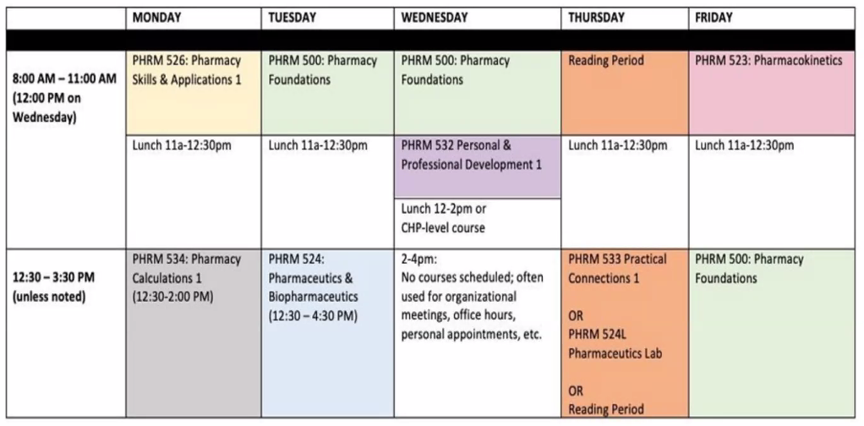

PharmD/MS Joint Degree
- Four-year joint degree
  - Combines 3-year PharmD curriculum with 1-year research-focused experience
    - Example courses: biochemistry, pharmacodynamics & pharmacokinetics interface, advanced topics in pharmaceutical sciences, scientific communciation
- For students interested in conducting original research on journey to becoming researcher-clinicians
  - Graduates have competitive advantage for pharmacy-focused career + training opportunities (in terms of academia, industry settings, residency programs)

Pacific Culture and Fit
- Open-door policy
  - Classes are on one side of the hallway; faculty offices are on the other side
    - Easier to connect with faculty/professors!
- Community driven
  - Serving the underserved
    - Experiential education (in rural + urban settings)
  - Strongly encourage involvement in community service
  - Student orgs: health fairs, community events
    - Flu + vaccination clinics in parking structure
      - Patients can drive through to get vaccine
- Student organizations
  - Ambassadors club
  - Student senate
  - Class officers
  - Kappa Psi
  - Professional Student Senate (PSS)
    - All CHP programs represented in PSS

Experiences of Current Pacific Pharmacy Students
- Ashley Mosesman (P1, 3-year program)
  - Faculty + students are really close → nice to have their support + mentorship
    - Meet twice a semester to follow up
  - Worked as pharm-tech while attending school
  - Why she chose Pacific
    - Always interested in getting masters in pharmaceutical sciences
    - Drawn to Portland area + 3-year program
- Hoda Veshagh (P2)
  - Why she chose pharmacy
    - Knew she wanted to be in healthcare field since she was young
    - Got opportunity to shadow family friend who owned an independent pharmacy overseas
      - Shadowed her for 3 years → fell in love with pharmacy
      - Attracted to communication aspect + mechanism of drugs
  - Why she chose Pacific
    - Introduced by a friend who was in the Pacific 3-year program
      - Learned about supportive + faculty community
    - Only applied to this school because she was set on going here
    - Was never able to connect to professors at her undergrad university
      - Pacific professors are very accessible & want to help you succeed
- Jasmin Schaefer (P1, 5-year program)
  - Why she chose pharmacy
    - Originally planned to go to pharmacy school straight out of undergrad
      - Recruited to PhD program at another university (got full ride)
      - Worked in biotechnology field after getting masters but kept coming back to pharmacy
    - Decided on 5-year program because it was better financially
      - Average 20 hours a week

Q&A Session
- Does AP Psychology cover for the psychology prerequisite?
  - Yes, AP classes (score of 4/5 will count) will count for non-science classes (e.g. calculus, economics, statistics)
  - Prerequisites must be completed prior to entering pharmacy program (July, 31st)
    - Can be in progress while applying
- Is both anatomy and physiology required?
  - Pacific requires that students do BOTH anatomy and physiology prior to starting school in the Gall
  - UCD students must take both the lecture and lab for both courses
- How is the cost of living? Do you live on/off campus?
  - Costs $1300-1800 for studio or one-bedroom apartment
    - Many students live around campus + take MAX line
    - Recommended to live with a roommate to lessen costs
  - Hoda took the MAX line (transportation service) the first year of school
    - Stops right in front of the school (very convenient)
  - Financial aid advisor is very flexible + accessible
    - Helpful for emergencies or if you didn’t take out as much money as you needed
    - Can request for as much financial aid as you want
- What kind of extracurricular activities are you involved in? Is it hard to balance school work and other activities?
  - Ashley
    - Part of Professional Student Summit (represents P1 class) & Pacific Pharmacy Association
      - Goes to meetings with other colleges
      - Provided free blood glucose checks at Farmers’ Market
  - Hoda
    - Kappa Psi
      - Many social gatherings/events where she met other students
    - Vice President of APHA
      - Focused on policy work
      - Starts meeting with a new policy (e.g. new drug on the market)
    - Egghead program (underserved program)
      - Get to do didactic work + independent studies
      - Great if interested in rural/underserved areas (not many pre-reqs)
        - Required to do 1 underrepresented rotation
    - Worked at Walgreens as pharmacy technician before entering Pacific
      - Not required to get pharmacy experience but it was helpful for the curriculum (get exposure to drugs)
  - All clubs meet at lunch time or after class
    - Not hard to manage time; just have to prioritize what’s important
  - Other extracurricular opportunities at Pacific
    - Pediatric pharmacy club
    - Research Track
    - Honor society
    - Journal Club
    - Industry Organization
    - Pharmacy Fraternities
- How many internships/lab experience did you have as an undergrad and how closely did they match what grad schools were looking for?
  - Lab experiences are not necessary but it’s good to add
  - Pharmacy is more of a community-based job
    - Any type of volunteering in community would be a valuable experience

Contact Information
- Tony Potter (Assistant Director for Graduate and Professional Admissions)
- Email: pharmd@pacificu.edu
- Phone Number: (503) 352-7229

